IW-16
YEAR 10 SCIENCE
EARTH AND SPACE SCIENCE
ASSIGNMENT - ORIGIN OF THE UNIVERSE

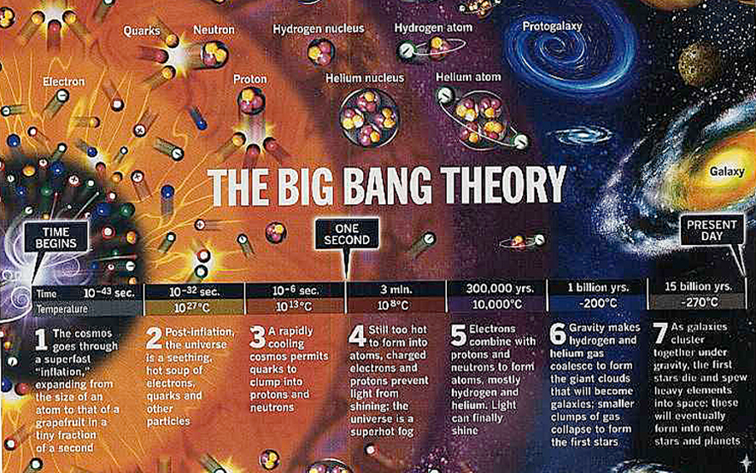

The research that you need to do for this assignment is divided into two main parts.

Either you can decide to deal with these as separate parts of your discussion or you can
mention both aspects throughout your discussion.

You MUST provide:

• Your research notes.
• Your written report.
• A reference list.

Task

Your research report shall:

1. give an explanation of the Big Bang Theory as it stands today and show how
the theory came about.
2. give the names and some history of the important people who helped to
develop the theory. Are there any Australians who have played a part?

CHECK THE RUBRIC TO MAKE SURE YOU HAVE HIT EACH OF THE CRITERIA
INCLUDED FOR MARKING.

(Hint: Einstein and Stephen Hawking are two scientists expected to be mentioned in
your research - they are NOT Australian, nor the only scientists involved.)
YEAR 10 SCIENCE
EARTH AND SPACE SCIENCE
ASSIGNMENT - ORIGIN OF THE UNIVERSE
MARKING RUBRIC

Name:

Achievement Standard (Science) | 0 | 1 | 2 | 3 | 4
Students evaluate the evidence for scientific theories that explain the origin of the universe.
I can give a clear explanation for the Big Bang Theory of the
origin of the universe.
I can present a range of evidence that led to the development of
the Big Bang theory.
I can clearly explain how the evidence supports the Big Bang
Theory.
Students analyse how the models and theories they use have developed over time and discuss the factors that prompted their review.
I can explain how theories are developed.
I can explain how new evidence can change or make scientists
review a theory (related to the Big Bang Theory).
I have acknowledged the discovery of recent evidence by an
Australian scientist that prompted further review and
modification of the Big Bang Theory.
Students construct evidence‐based arguments and select appropriate representations and text types to communicate science ideas for specific purposes.
I have been able to link evidence to any modifications to the
theory each time a new piece of evidence has been proposed.
I have used words appropriate to a general audience.
I have referenced all my sources of information.
I have made all information that I have given easy to read and
understand by making sure I have explained all scientific terms
that I have used.
TOTAL

COMMENT

